Anse Cochon inquiry first sitting evidence dossier

Public sitting of 13 October 2026
By Kevin L. Michel · Saint Lucia Policy Analysis · Published 14 October 2026
This dossier examines all three transcript parts of the first public sitting on 13 October 2026, alongside public records, maritime legislation and vessel photographs reviewed through 14 October. The evidence cutoff for hearing testimony is the close of the 13 October sitting. Later testimony is not included. The sitting ended; the inquiry did not. No final determination of fault appears in this record.
Source note. The supplied automated transcripts are not certified verbatim records. Some names, words and speaker changes are uncertain. Statements are paraphrased unless quotation marks appear; quotations reproduce the supplied text and have not all been checked against the recording. Part I citations use elapsed recording offsets. Parts II and III use editorial passage identifiers, not hearing times. The source text is preserved unchanged in the companion transcript edition.

What the full day establishes and leaves unresolved
The evidence already supports serious questions about how these voyages were operated and supervised. Dylan Nicholas accepted that Ocean Angel left Soufrière without navigation lights switched on, that nobody wore a life jacket, that no safety briefing took place, and that he did not report the departure to the lighthouse. Tyson Hippolit, the other boat's captain (surname spelling unverified), accepted an expired licence document and acknowledged operating without a current licence. Both accounts raise questions that are independently important, even before the precise collision sequence is settled. [P1 02:21:09–02:22:10; 02:33:25–02:39:27; P2-045, P2-049]
The record does not yet establish which vessel's action caused the collision, the exact point and angle of contact, intoxication, the contribution of rescue timing to particular deaths, or a final regulatory failure. Those questions require the original exhibits, physical evidence, complete witness accounts and operational records. A public inquiry's probing questions can expose weaknesses without becoming its findings.
Six people give substantive sworn evidence across the supplied parts: the police investigator, two Ocean Angel passengers, Ocean Angel's operator, Cazorla Jr.'s captain and, in Part III, its owner Ireanius Pascal. His first-name spelling remains provisional. Pascal accepts that he did not check Tyson's licence and says that Graham Matthew, the master named on Cazorla Jr.'s paperwork, never actually drove for him. He identifies Daryl Paul as his regular captain. This makes the relationship between certification and actual operation a central reporting question. It does not establish that SLASPA knowingly approved an improper arrangement. [P3-001–P3-004, P3-018, P3-033–P3-044]
The owner also gives direct evidence that Cazorla Jr. sank after the collision. At the 13 October sitting, the record exposed an unfinished investigation file, missing statements and overdue logs. These are the records that could settle disagreements about lights, courses, calls, staffing and rescue. The Commission adjourns to 14 October at 10 a.m., according to the closing transcript; that is an announced sitting, not confirmation of what subsequently occurred. [P3-052–P3-057]
This account distinguishes what witnesses accepted, what other evidence supports, and what the record still cannot resolve. A witness statement, an examiner's proposition and a Commission finding are identified separately.

What the final part of the sitting adds
Question raised earlier in the sitting | Evidence added by Part III and photo research
Owner announced but not heard | Pascal now gives sworn evidence and adopts his 19 July statement; six oral witnesses across the day
Cazorla engine specification unclear | Pascal clearly confirms 150 hp; brand, model and engine inventory still unverified
Sinking supported mainly by early reporting | Owner now describes post-impact loss of steering, an attempted move toward shore and sinking
Cazorla manifest largely unfilled | Five people linked by testimony: Tyson, Pascal, Mavado/Butcher, Taylor and Roman; four places unresolved
Named master absent from incident voyage | Owner says Graham Matthew never drove for him; Daryl Paul was the regular skipper; actual helm was Tyson
Boat appearance only conceptual | Mango Tours photograph bears SL078180. Ocean Angel #3 is the highly likely working identification after further photo research; differing 857 and 875 markings remain unresolved

“Established” in this dossier is graded. A witness's admission establishes what that person accepted under oath. An independently checked public document establishes what the document says. Neither automatically establishes causation. Commissioner questions, characterizations and hypotheses remain separately attributed. No final Commission determination of fault appears in the three transcripts.

1 The event the people and the Commission
The collision occurred off Anse Cochon on Saint Lucia's west coast on the night of Saturday 18 July 2026. A police statement issued on 22 July identifies four deceased people: Mhakeida Nestor, Debbie Dolor, Marley William and Tyrone Elivique. It reports fourteen injured people treated at Soufrière Hospital, with serious cases transferred, and recovery of wreckage from both vessels. Police described Ocean Angel as northbound and the other boat, called Mango Tours in early reporting, as southbound. [S03]
Those directions are useful map context. They do not demonstrate an exactly head-on encounter. The police statement's 11:55 p.m. reference concerns the Marine Unit's response to a report. It should not become an independently verified second-by-second impact time. The two male victims were recovered on 22 July; the recovery date must not be confused with the collision date. [S03]
There is a real identity discrepancy to handle respectfully. The 13 October transcript uses Tyrone Paul. August reporting interviewing his sister Dalpha Paul also uses Paul, then Elivique in the same article. This dossier refers to Tyrone Paul, named Tyrone Elivique in the July police update. The differing surnames do not indicate a fifth victim; the identity crosswalk still requires records or family confirmation. [S03, S05]
The official Commission roster is:
Person | Role
Retired Justice Mario Michel | Chairman
Cuthbert Didier | Maritime consultant; commissioner
Kentry Frederick | Retired Superintendent of Police; commissioner
Luke De Freitas | Assistant Commissioner of Police; commissioner
Shahida Charlemagne-Octave | Legal counsel to the Commission
Lenita Joseph | Secretary

The government's September announcement records swearing-in on 8 September 2026 and a report deadline of 8 March 2027. It names Ocean Angel, SL077875, and Cazorla Jr., SL078180. [S01]
Two source conflicts remain in the verification ledger. The chair says the appointment instrument was issued 1 September, while the September government release says appointment 4 September. Separately, the government's 9 October notice prints Ocean Angel's number SL077857, whereas the September notice uses SL077875. Subsequent photographs show apparently differing number endings, so a typographical transposition can no longer be treated as the settled explanation. Historical registry entries, certificates and the original appointment instrument are needed to resolve those discrepancies. This dossier preserves each source reading; copied notices do not provide independent confirmation. [P1 00:03:29–00:04:59; S01–S02]
The mandate covers the collision, relevant maritime law, safety and investigation procedures, and recommendations for reform. The chair expressly distinguishes this inquiry from a criminal prosecution. He also sets aside extended examination of a separate yacht trespass/assault case. Any coverage of that case must keep alleged conduct and charges separate from proved wrongdoing. [P1 00:05:43–00:13:49]

2 Which boats were involved and what happened to them
Question | Ocean Angel / Ocean Angel III or 3 in testimony | Cazorla Jr.
Registered identity | Government September notice: SL077875; October notice: SL077857 | Government notices: SL078180
Journey | Northbound from Soufrière; intended northern destination described as Gros Islet | Southbound return to Soufrière after an earlier Gros Islet trip
Person at helm at impact | Dylan Nicholas, by his own account and passenger evidence | Tyson Hippolit, by his own account
Persons aboard | Nine total: two crew and seven passengers in Dylan's explicit breakdown | Nine total in Tyson's and Pascal's evidence; five people linked, full manifest unavailable
Type and appearance supported | Open motorboat with red interior and pale hull in the photo set; Ocean Angel #3 highly likely as a working identification. Apparent 857/875 endings, hull history and photo dates unresolved | Early police-attributed reporting calls Mango Tours a pirogue; a Mango listing photograph shows SL078180, matching official Cazorla Jr. identification
Engine evidence | Dylan says one 200-horsepower engine | Pascal expressly confirms 150 hp in Part III; make/model not confirmed
Damage and immediate condition | Dylan describes splitting in half and overturning; passengers describe floating fragments and the overturned craft | Pascal describes steering disconnected after impact, engine running, an attempted move shoreward and sinking; Tyson describes neutral selection and rescue
Final disposition | Wreckage from both boats reported recovered by 22 July; neither established as a serviceable survivor | Same limitation

[P1 01:31:20; 02:09:34; 02:18:22–02:19:07; 02:43:26–02:44:52; P2-036, P2-041, P2-043; P3-045, P3-052–P3-053; S01–S04, S09, S14–S15]
The direct answer is now firmer: Pascal says Cazorla Jr. sank. Ocean Angel witnesses describe breakup and overturning. Neither vessel is established as a serviceable survivor. July reporting says wreckage from both was recovered. A temporarily floating overturned hull supporting survivors is compatible with severe loss. [P3-052; P1 02:43:26–02:44:52; P2-005–P2-009; S03–S04]

The actual vessel photo leads
A Mango Tours listing photograph visibly shows SL078180 on a white hull with a blue interior. That number matches the government's Cazorla Jr. identification and provides substantially stronger evidence than paint colour or a business name alone. The image's capture date and original upload date have not been authenticated. Describe it as a registration-matched vessel photograph of uncertain date, not a conclusively dated pre-collision photograph. [S01, S09]
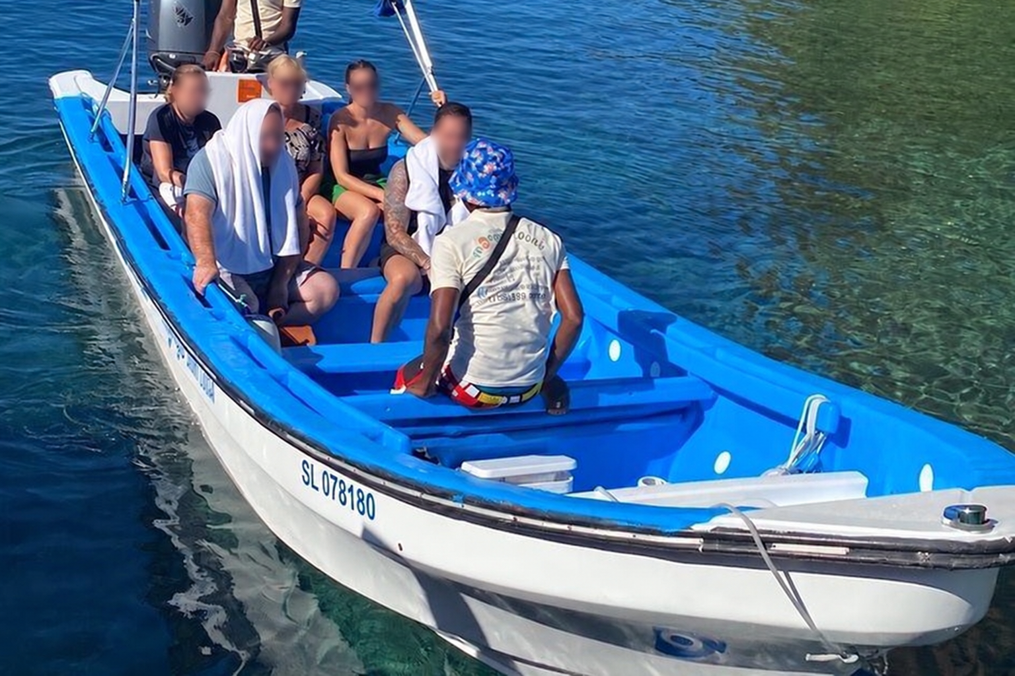
Privacy-edited display copy of a Mango Tours vessel photograph with registration SL078180, matching the inquiry identification of Cazorla Jr. Faces softened for privacy using an AI-assisted edit; the unedited source is kept in the research archive. The photograph is undated and does not establish the collision-night configuration. The people pictured are not identified here as accident passengers.
SLPA adopts Ocean Angel #3 as the highly likely working identification, consistent with the vessel named in the hearing. This editorial assessment draws on the visible #3 marking in the background of a two-boat photograph, the open layout and one-outboard references, the associated number strings, and additional research supplied by Kevin L. Michel. Those lines of evidence converge on a useful working identification without establishing a certified number-to-hull history. Similar upholstery or canopy supports alone cannot establish that every image depicts the same physical hull. [P1 00:35:47–00:36:50; S10–S11, S14–S15]
The beach photograph shows OCEAN ANGEL, an apparent SL077875, a pale hull, red interior, blue canopy and one visible outboard. Its digits are soft. The background #3 vessel in the two-boat photograph appears to carry an ending 857. These observations make the number question substantive: neither official notice can yet be dismissed simply as a printing error. No image supplies a verified date sequence that could demonstrate a change over time. [S01–S02, S14–S15]
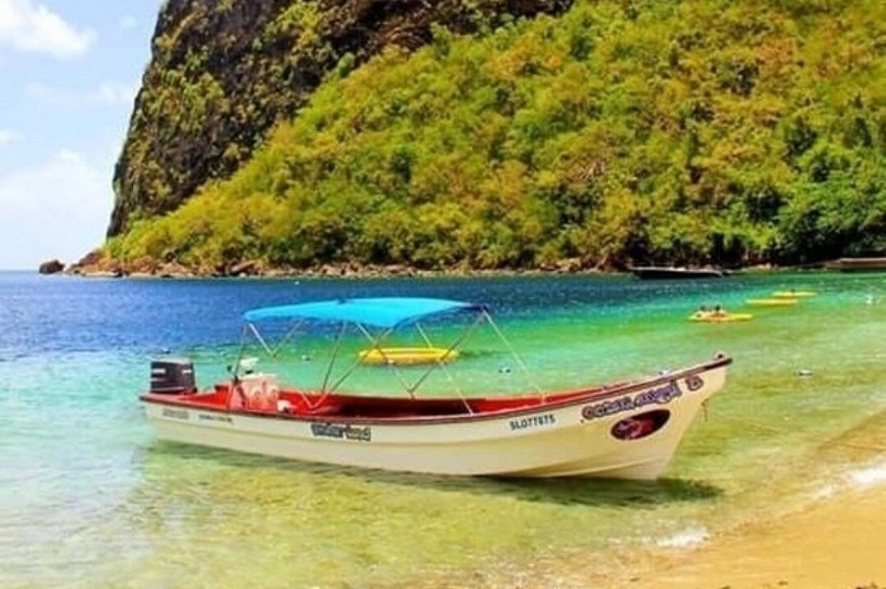
Ocean Angel photograph supplied to SLPA [S14]. The hull appears to bear SL077875, but the digits are soft. The broader photo review supports Ocean Angel #3 as the highly likely working identification; another #3 view appears to end 857. The registration history, original source and dates remain unresolved. This particular view establishes no visible III or 3 suffix.
The empty-interior WEBP repeats the composition of an earlier archived JPEG; the two encodings are not independent corroboration. The selected bow and empty-interior views help explain the narrow open layout, transverse red-and-white benches and aft steering console. The empty-interior view has one visible Yamaha outboard and a partial life-ring marking 3; it does not show a full registration or vessel name. The bow view gives a partial OCEAN name but no readable registration. Neither identifies the people aboard on 18 July, establishes the engine then installed, or proves the navigation lights' condition. Both retain unknown original capture and publication dates. [S15]
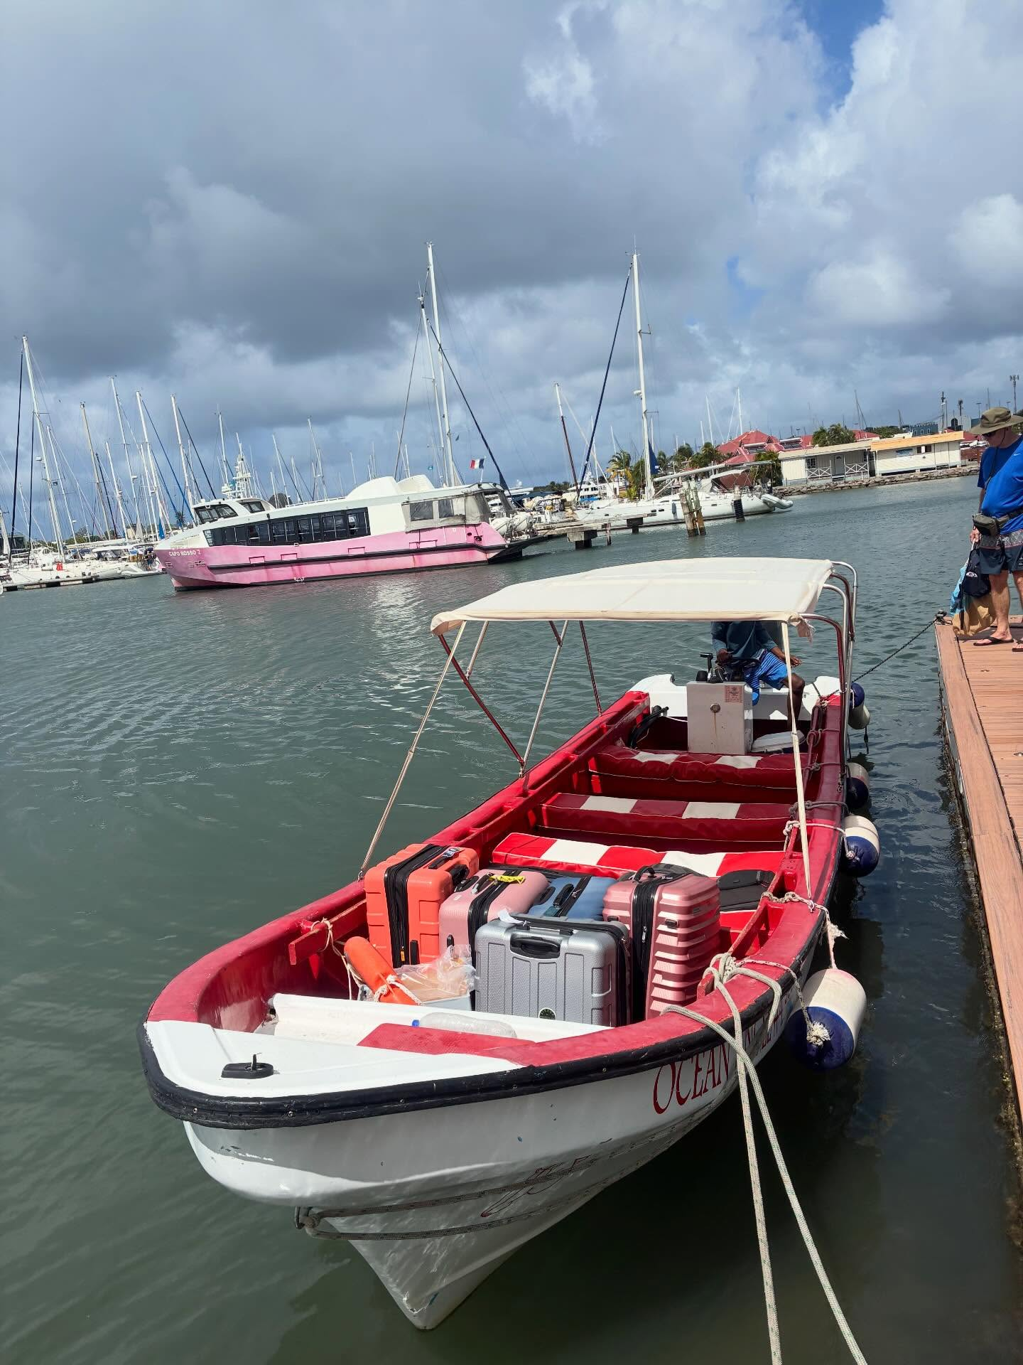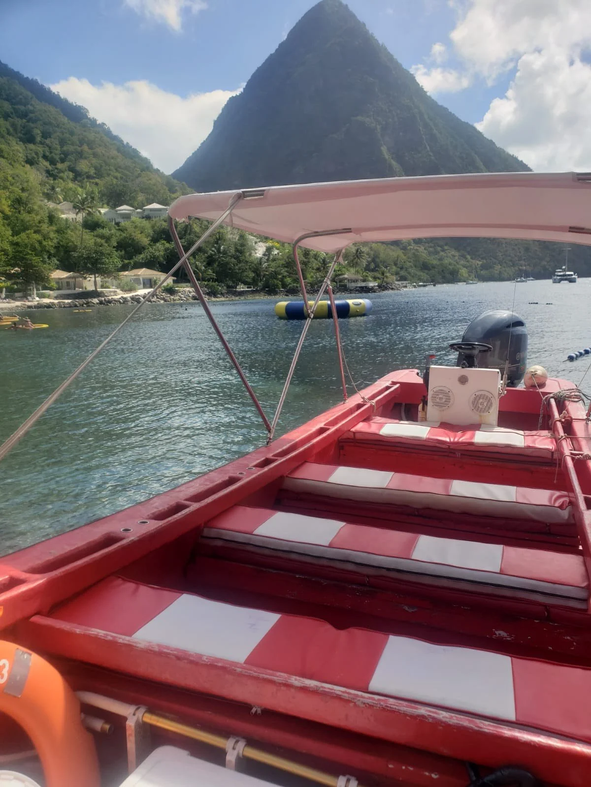
Selected structural reference photographs [S15]. Left: bow view with transverse seating and aft console. Right: empty interior with one visible Yamaha outboard. These undated views support the highly likely Ocean Angel #3 assessment but do not independently establish a unique hull, collision-night configuration or registration history. No person is identified from appearance.
Could one hull have had both official numbers? The Shipping Act allows registration anew after certain material alterations and, on application at the Registrar's discretion, following ownership change. Section 47 provides for a new register and certificate. Those provisions do not themselves establish that a different official number is allocated. We have not verified a number-retention or reallocation rule, nor a registry chain linking these two numbers to the same hull. A repainting error, a document error, different hulls or a documented administrative change remain possibilities to test, not findings. Extracts for both numbers, historical certificates, alteration or cancellation entries, carving and marking notes, and hull or builder identifiers could resolve the number-to-hull history. [L32–L34]
Ocean Angel 1 and 2 are excluded from the active incident-photo candidates: the #2 photograph carries the different registration SL077776; #1 shows twin outboards, and Kevin reports reviewing pre- and post-incident imagery that rules it out. A website listing alone does not establish a vessel's current condition or seaworthiness. Earlier unidentified fleet and profile images remain secondary archival references. [S10, S12, S14]
A December 2023 traveller review names Ocean Angel 3, Dylan and Elias but has no attached photograph. The January 2021 Gazette also lists Ocean Angel 3rd with a six-person capacity in a COVID compliance table. Neither source supplies a unique hull identifier connecting the historical vessel to every later photograph; the 2021 entry does not establish the permitted 2026 capacity. The companion gallery preserves the selected actual photographs with provenance and confidence notes. Public visibility does not by itself establish publication rights. [S11, S16]
Photographs explain visible vessel form; they do not establish who was aboard on the collision voyage or how contact occurred. Illustrative models cannot supply missing measurements or physical evidence.

3 Who was aboard
Elias Nicholas initially gives an uncertain total, then agrees to the chair's count of nine named or described people on Ocean Angel. This broadly agrees with Dylan's explicit total. It is a useful working manifest, not a checked departure list. [P1 02:18:22–02:19:07; P2-031]
Ocean Angel entry | Role or identification in testimony | What can responsibly be stated
Dylan Nicholas | Captain at impact; managing director of Ocean Angel business | Sworn witness in Part I
Tyrone / Tyran | Initial operator, then first mate/lookout according to Dylan | Transcript later uses Paul; police casualty naming uses Elivique; reconcile original identities
Roxan Bonapart | Passenger | Sworn witness in Part I; name rendered Roxan Bonapart in the supplied transcript, spelling unverified
Elias Nicholas | Passenger and fisherman; says not crew | Sworn witness in Part II
Debbie | Passenger; Elias says he later saw her body on rescue boat | Full-name match to the police casualty record remains unconfirmed
Unnamed woman from Choiseul | Passenger described by Elias | Keep unnamed; do not assume she is Mhakeida Nestor solely by elimination
Bradley | Passenger; first name spelled in questioning | Full identity and individual outcome unconfirmed here
Marvin | Passenger; ASR variants | Full identity and outcome unconfirmed here
Marley | Passenger; ASR also produces Mali/Molly | Likely identity must still be checked against records; no silent crosswalk

For Cazorla Jr., Tyson and Pascal say nine were aboard. Pascal confirms he was on the boat and identifies the following additional people. These are testimony-linked entries, not a checked manifest. [P2-036; P3-003–P3-010, P3-020–P3-021, P3-028]
Cazorla Jr. entry | Role supported by the hearing | Remaining verification
Tyson Hippolit / Hippolyte | Captain on both journeys | Official spelling, licence and full statement
Ireanius / Ireneius Pascal | Owner aboard; takes controls after impact in his account | Official first-name spelling and ownership extract
Janelle / Jonel Butcher, alias Mado / Mavado / Movado | Return-leg lookout; alias-to-name identification put on record and accepted | Witness list, statement and precise assigned duties
Taylor River / Rivier | Passenger; paid funds for herself and boyfriend; requested his jacket, owner says | Match to police-file name and statement
Roman / Rome William | Taylor's boyfriend; jacket requested for him | Match to police-file name; whether, when and how he wore it
Four unresolved places | Remainder if the reported nine-person total is correct | Complete outward and return manifests; any boarding changes

The earlier drinks reference to Lester and Nile does not, by itself, fill two of these places. Daryl Paul is the regular skipper who Pascal says went to the event in his own small boat; he is not placed aboard Cazorla Jr. during the collision. Graham Matthew is named on the paperwork; Pascal says he never drove the vessel. Neither should be inserted into the casualty manifest. [P2-051; P3-034–P3-042]
The seating evidence is partial. Bonapart places herself two benches forward of the stern captain, with two people beside her, three behind, and two ahead. Elias places himself forward on the left with Tyrone beside him. These accounts can inform a generic seating diagram, but no precise hull plan or placement of every person is established. Both passengers describe their own view being obstructed by the forward bow; that does not prove the captain had the same sightline. [P1 01:23:35–01:24:41; 01:51:56; P2-014–P2-015]

4 What can be reconstructed about the night

Departure and change of operator
Tyson describes taking his boat from Soufrière to Gros Islet around 3 p.m., then making the return trip. Elias places his own boarding of Ocean Angel sometime after 10 p.m. Bonapart's statement refers to Dylan collecting her shortly after 11 p.m.; she cannot give the boat's departure time. These are different events and approximate recollections, not an exact timetable. [P2-002, P2-036; P1 01:25:23]
The three Ocean Angel accounts agree that Tyrone first steered and Dylan later took over. Dylan locates the change near Anse Mamin. Elias's place name is corrupted and must be checked against audio. Bonapart and Elias say Dylan drove faster; both recall a remark suggesting he would demonstrate how to handle the boat. Dylan disputes the speed increase and does not accept the quoted remark. The unstable automated wording does not support a reliable exact quotation of that disputed remark. [P1 01:21:35–01:22:56; 02:08:40–02:09:34; 03:09:14–03:11:25; P2-003–P2-005]

The southbound journey and the owner s correction
Pascal says Tyson captained both journeys. He places a request to slow down near Windjammer after the return departure and says Tyson complied immediately and did not later accelerate again. This is a distinct account from the alleged ignored warnings on Ocean Angel. It supports that a speed concern was expressed; it does not supply a measured speed at the collision. [P3-010–P3-011, P3-019, P3-027]
Pascal initially says Roman requested a jacket about ten minutes before collision, then explains that Taylor asked on Roman's behalf, after the slowdown, and that the boat stopped to retrieve it. He gives an approximate ten-to-twenty-minute slowdown-to-request interval and separately estimates fifty minutes to an hour from slowdown to collision. The request-to-impact and slowdown-to-request intervals describe different endpoints and can both be true; the separate fifty-to-sixty-minute total requires reconciliation. These approximations do not provide a synchronized timeline. The original statement and other passengers' accounts could clarify it. [P3-008, P3-019, P3-027–P3-028]
His departure estimate shifts from after 10 p.m. to around 10:45 p.m.; he associates impact with 11:55 p.m. and later says that is what others say. He first separates the Windjammer-to-impact interval from the full trip, then gives variable overall estimates. These are recollections with corrections, not independent clock readings or a defensible speed calculation. [P3-045–P3-046, P3-050–P3-051]

Warnings lights and preparation
Bonapart says she requested a life jacket because she could not swim and was told she was safe with Dylan. Elias says three women asked Dylan to slow down, saying they could not swim, and that he neither slowed nor replied. Dylan denies being asked to slow down. Elias later answers a question specifically excluding the women, saying nobody else objected. The chair then restates this as a general denial; Elias reaffirms the women's warnings. The narrower question matters: this is not an unexplained reversal by the witness. [P1 01:16:47; 03:11:25; P2-016, P2-033]
Several points have firmer footing because Dylan himself accepts them: nobody wore a life jacket; no briefing was given before departure or after he assumed the helm; the navigation lights were off at departure and he knew they were off while Tyrone initially steered; he did not make the lighthouse report; and he did not perform his usual departure equipment check or read the weather advisory. He says fourteen life jackets and other safety equipment were aboard. Carriage, accessibility, instruction and actual use are separate questions. [P1 02:33:25–02:39:27; 03:38:04–03:39:27]
The lights immediately before collision remain disputed. Dylan says he switched them on at the helm change. Bonapart and Elias say they saw none during the trip. Dylan says the forward fixtures were outside passengers' view. Tyson says Cazorla Jr.'s lights were on and he saw only shore lights before impact. Both masters say a lookout had been assigned; neither reports receiving an effective warning about the other craft. [P1 02:14:55–02:18:22; 02:37:40–02:39:27; 02:49:32–03:01:14; P2-017, P2-041, P2-044]
Pascal accepts no safety briefing, no routine distribution of life jackets, no flares, no forecast check for this outing and no lighthouse/VHF report. He describes a working radio that was unused and clarifies that the navigation lights were operating. The ambiguous sentence about equipment not being used must not be extracted to imply he admitted the lights were off. He says no lookout was assigned outbound but Mavado served on the return. He could not see beyond the bow from his own seat. His claim that an unlit oncoming craft might not be seen is an inference, not an observation that Ocean Angel's lights were off. [P3-004–P3-009, P3-020, P3-025–P3-033]
The official 6 p.m. forecast on 18 July provides an independently checkable warning backdrop: locally rough seas, northeast-to-east swells of 6–9 feet (1.8–2.7 m), gusty east-to-east-northeast winds around 23 mph, some showers, and small-craft caution. This was a regional marine forecast covering waters within 25 miles of Saint Lucia, not measured conditions at the collision point. It strengthens the question of whether the operators consulted and applied the forecast; it does not settle whose description of local visibility or waves was correct. [S08]

Collision a sequence that cannot yet be drawn precisely
Dylan says he saw red and green lights ahead and turned starboard, immediately correcting an initial “port” answer. He recalls the other craft at his starboard side. His later difficulty identifying a last clear pre-impact memory limits the precision of that recollection; it does not erase the earlier account. A commissioner puts a different proposition to him: damage on Ocean Angel's port side and the other vessel's starboard side, suggesting a crossing collision. Dylan has not inspected the wreck. Elias does not see the approach or contact; his later suggestion of a right-side impact is an inference from his own survival and seating position. Bonapart has a memory gap between the life-jacket exchange and finding herself in the water. [P1 02:15:34; 02:27:48–02:30:39; 03:40:07–03:40:49; 01:34:48; P2-025–P2-026]
That leaves competing recollection, an unexhibited damage proposition and survivor inference. It is insufficient for a precise impact animation. A valid reconstruction needs physical marks on both hulls, contact heights and directions, possible roll/trim, courses, speeds and timing. Northbound and southbound route arrows should not be repurposed as collision vectors.

Survival and rescue
Bonapart recalls holding floating boat material and receiving a life jacket from someone she cannot identify. Dylan says he supplied it. Elias says he grabbed a floating jacket, climbed onto the overturned craft and saw Dylan trying to make a phone call. These accounts partly support each other while leaving the caller's location and sequence unresolved. [P1 01:19:35; 01:41:37–01:43:06; 02:40:08–02:44:11; P2-006, P2-024]
Dylan says he called marine police and Soufrière contacts, then searched for others. His oral description of a floating jacket differs from his police statement's description of retrieving one underwater. He cites injuries and an exhausting interview as possible sources of imperfect memory. That inconsistency needs clarification; it does not establish intentional falsehood. [P1 02:42:37–02:47:03]
Bonapart says one southbound boat passed without stopping and another responded after a phone light was flashed. The record does not establish that the first crew saw the people or knowingly ignored distress. Elias estimates about fifteen minutes to rescue, remembers Debbie's body on his rescue boat, and describes landing at Canaries before losing awareness and next recalling hospital. He specifically corrects a suggestion that Debbie had been on the overturned craft. [P1 01:27:21–01:28:06; 01:36:35–01:38:03; P2-008–P2-011]
Tyson says he put the engine in neutral and seconds later entered the water and saved two people; identities are not supplied. His initial statement that he stayed at the wheel can describe the first seconds rather than contradict later entry into the water. None of these recollected intervals substitutes for call, launch, arrival, transfer and medical logs. [P2-043]
Pascal supplies the first substantial owner account of Cazorla Jr.'s final minutes. He says Tyson went to assist after cries for help. Pascal took the controls while Mavado went to the engine because steering was disconnected although the engine was running. They attempted to bring those still aboard closer to shore; the boat sank before reaching far. Pascal says he grabbed a life jacket, swam to a nearby yacht or catamaran and borrowed a phone to call his aunt. He explains the choice by panic and remembering her number. These statements do not establish the delay until the first emergency alert by anyone, or the fate of every occupant. The yacht/catamaran is a refuge he reached, not one of the two collision vessels. [P3-052–P3-053]
Post-impact steering failure must not become a pre-impact mechanical-cause claim. Tyson's earlier neutral selection and Pascal's subsequent powered attempt can describe successive actions; the transcript does not justify calling them irreconcilable. Equally, Pascal's description of Mavado being thrown out and later helping at the engine leaves a missing reboarding step. Ask about that sequence rather than invent it. [P2-043; P3-048, P3-052]

5 What each witness adds
Witness | Most consequential contribution | Important limit
Corporal 153 Luciano — surname unverified | Police file incomplete; missing statements and documents; SLASPA coordination described | Appearance primarily to tender records; substantive investigative conclusions deferred; surname unverified
Roxan Bonapart | No life jackets worn or briefing; unlit departure and claimed unlit voyage; increased speed; life-jacket request; partial rescue narrative | No measured speed; cannot recall impact or identify jacket provider
Dylan Nicholas | Admissions about departure lights, briefing, jackets, reporting and checks; own turn/lights/rescue account; certificate challenge | Directly disputed on lights and speed; memory limitations; technical reconstruction absent
Elias Nicholas | Working nine-person manifest; corroborating speed/light concerns; three women's alleged warnings; capsize and Canaries rescue | Obstructed forward view, injuries and awareness gaps; collision-side inference not observation
Tyson Hippolit | Expired-licence acknowledgement; four beers admitted; no lighthouse call; lights/lookout and two rescues claimed | No verified full manifest, measured track/speed, alcohol testing or identified rescue corroboration
Ireanius Pascal | No licence check; safety omissions; named master versus actual staffing; 150 hp; slowdown; sinking and initial call | Cannot see approach from own seat; approximate times; reports others' lookout observations; no technical survey or SLASPA response

One important difference concerns contact with Elias. The investigator says an initial statement attempt failed because Elias was injured and that he made no later attempt. Elias says no officer came to obtain a statement. This warrants the contact diary and a precise account of attempted visits, communication and medical access. Neither statement alone resolves the discrepancy. [P1 00:45:21; P2-001]

Which conflicts survive a close reading
The useful distinction is between a witness changing an account, different witnesses disputing the same event, and an answer corrected or distorted by the question. None automatically proves dishonesty. Credibility assessment should explain why the difference matters, whether it remains after clarification, and what evidence could resolve it.
Material self-inconsistencies remain. Dylan's oral description of a floating life jacket differs from the underwater retrieval described in the statement he had adopted. His injury-and-interview explanation is relevant but does not establish which action occurred. Pascal's intervals between slowdown, jacket request and collision do not settle into one reliable clock: roughly ten minutes from request to impact, ten-to-twenty from slowdown to request, and an initial fifty-to-sixty from slowdown to impact cannot be confidently synchronized. Dylan's descriptions of routine briefing practice also vary between not doing it much, normally doing it and sometimes doing it. The concrete omission that night is clearer than the general frequency. These warrant clarification, not a summary label that a witness lied. [P1 02:40:08–02:48:49; 02:34:30–02:36:13; 03:42:30–03:44:48; P3-008, P3-019, P3-028, P3-045–P3-051]
Important inter-witness disputes remain. Dylan denies the speed increase and ignored warnings that Bonapart and Elias describe. He says the navigation lights were on after the helm change; the passengers say they saw none. Their perception and the lights' physical operation must be tested separately. The investigator's attempted-contact account differs from Elias's statement that no officer came; a contact diary and medical-access record could reconcile or sharpen that discrepancy. The described sides of collision also conflict, but Elias's survival-based inference and a commissioner's unexhibited damage proposition are not additional independent eyewitness sightings. [P1 03:08:27–03:11:25; 02:49:32–03:01:14; 00:45:21; P2-001, P2-016–P2-017, P2-025–P2-026]
Several corrections improve rather than discredit the account. Dylan first says port and immediately corrects to starboard; do not invent two turns. Pascal clarifies that Taylor requested the jacket for Roman, corrects the suggestion that his insurer rejected Daryl, and withdraws certainty about what the lookout could see. Elias's name-by-name count resolves eight/nine uncertainty, and his evidence distinguishes Debbie's body on the rescue boat from people on the overturned hull. Each clarification should travel with the initial answer when reported. [P1 02:15:34; P3-028, P3-032–P3-033, P3-035–P3-036; P2-011–P2-013, P2-031–P2-032]
Some supposed contradictions are created by wording or missing steps. The speed-warning question excluding the women becomes misleading when restated without that qualification. Elias's “stable” versus a questioner's “unstable” requires audio; the text cannot establish whether ASR or the restatement caused the discrepancy. Discomfort and absence of fear for one's life are different thresholds. Tyson staying at the helm initially and entering the water seconds later can both be true; neutral selection and a later running-engine manoeuvre can also be successive acts. Butcher being thrown out before helping at the engine leaves a reboarding step to ask about. None should be flattened into either a proven contradiction or a fully verified sequence. [P2-016, P2-019, P2-025, P2-031–P2-033, P2-043; P3-048, P3-052]
Each unresolved difference needs the full question and answer, the witness’s explanation and any independent record capable of testing it. Memory limitations and corrections remain part of the evidence. An absence of contradiction is not corroboration, and agreement between accounts does not itself prove they were independently formed.

6 Licensing alcohol and the risk of premature conclusions
Shown a licence said to expire on 18 July 2015, Tyson accepts that date and acknowledges operating without a current licence. This is a substantial admission. The document should still be obtained: class, endorsements, renewal history and any other credential matter. An expired licence is not the same as never having trained, and it does not determine which vessel caused a collision. His suggestion that fishing operations are treated differently requires the actual legal categories. [P2-037, P2-049]
Dylan reports a Grade II licence and several years of commercial experience. A commissioner says Ocean Angel's inspection certificate names Graham Matthew as minimum certified crew, while the other boat lists Matthew as Boatmaster. Nicholas agrees Matthew was absent and says he did not understand the manning restriction. This raises concrete questions about certification and substitution, but the legal effect must be checked against the complete documents and any approvals. [P1 03:25:08–03:28:05; 03:36:08–03:38:04]
Nicholas also denies that a signature on an inspection certificate dated 23 January 2026 is his. We do not yet know whose signature the field required, who signed, or whether an authorised representative could do so. The accurate description is a challenged signature, not forgery. [P1 03:28:05–03:30:31]
Dylan's initial coffee-and-water answer concerned a misunderstood time frame; it should not be presented as an exposed denial of earlier alcohol consumption. Once the period was clarified, both operators described alcohol consumption: Dylan describes two shandy-like cocktails with dinner; Tyson accepts at least four Piton beers and denies further drinks. Tyson's self-assessment that beer did not affect him is not a clinical finding, but neither is the chair's skepticism proof of impairment. Without drink size, strength, timing, food, tests or clinical evidence, no blood-alcohol calculation or causal conclusion is justified. [P1 03:01:14–03:03:44; P2-040, P2-051]

The certificate and staffing gap sharpened by Part III
Function | Person identified | Status of the evidence
Owner | Ireanius Pascal | Own admission and document described in questioning
Master named on Cazorla Jr. document | Graham Matthew | Document read in hearing; owner accepts name used and says he never drove for him
Regular working skipper | Daryl Paul | Owner says used for two to three years, then listed as crew following SLASPA grade objection
Captain on the collision voyage | Tyson Hippolit | Captain and owner agree; owner says substitution followed regular skipper's unavailability
Return lookout | Mavado / Janelle Butcher | Owner account; own oral evidence not supplied

[P3-018, P3-020, P3-033–P3-044]
Pascal says he assumed Tyson had a licence from knowing his experience and made no check. He says SLASPA required a different grade for his regular skipper, so Graham Matthew's name was put on the paperwork. He maintains Daryl was licensed to operate, previously accepted for the same unchanged vessel and accepted by his insurer. The exact grade discussion is confused: the transcript includes varying references to grades two and three. It cannot settle the licence hierarchy, endorsements or permitted substitutions. This is evidence of Pascal's account of the process, not SLASPA's answer. [P3-015–P3-018, P3-033–P3-042]
The document described in Part III bears a 22 May 2026 stamp and an inspection-certificate expiry of 22 November 2026. Graham's licence is read as expiring 28 September 2026. That expiry is after the 18 July collision: it cannot prove his licence had already expired that night. Different document expiry dates are not, on their own, invalidity. This is a different document from the January certificate whose signature Dylan challenged. Pascal's use-of-name admission does not prove a forged signature, an insurer's knowledge or official complicity. [P3-036, P3-040–P3-044]
Pascal also says he bought three or four rounds of beer and drank roughly three or four glasses of Bounty-and-cranberry, as transcribed. A questioner characterizes at least four drinks for Tyson. Pascal’s rounded purchase account and Tyson’s own admission are distinct pieces of evidence. No alcohol test or clinical impairment finding is supplied. [P3-011–P3-012, P3-030; P2-040, P2-051]

7 What SLASPA has to do with this
SLASPA's Division of Maritime Affairs describes responsibilities covering vessel surveys and certification, registration and licensing, capacity and manning, seafarer qualifications, casualty investigations and support to police search-and-rescue operations. A contemporaneous attributed SLASPA statement says police led the collision investigation while the division provided regulatory and technical support. This is a reason to examine specific records and decisions, not to assume SLASPA alone controlled every voyage or rescue. [L1; S07]
Four statuses must remain separate:
Status | The question to answer
Vessel registration | Which physical craft is this, and who is registered in relation to it?
Inspection and commercial operating permission | Was its certificate/licence current, with what equipment, area, passenger, crew and time restrictions?
Individual operator licence | Did the person at the helm hold an in-force qualification appropriate to the vessel and voyage?
Actual voyage compliance | Were lighting, lookout, speed, manning, equipment, reporting and other conditions met that night?

A registered boat can make a noncompliant voyage. An appropriately licensed captain can omit required precautions. A survey certificate does not prove everything remained serviceable after inspection. Conversely, a collision does not itself prove an inspection was deficient.
The published Shipping Act requires a current inspection certificate and compliance with its operational and manning conditions. The Small Commercial Vessel Code addresses appropriate Boatmaster qualifications, revalidation and predeparture operational checks. Grade II alone should not be described as a blanket daylight-only licence; any relevant night restriction must be traced to the actual licence, certificate or applicable rule. [L2, L4, L9]
The Code's published licence table does specify Grade III for open boats in protected/coastal waters in daylight, while its coastal passenger-vessel category under 12 metres specifies Grade II. Individual restrictions also matter. The confused grade references in Pascal's answers therefore need original documents, not a guessed hierarchy. The Code has scope limits and exclusions, including certain small craft carrying twelve or fewer passengers certified under a specially designed code. Each vessel’s actual survey regime and applicable instruments are needed to assess a specific statutory breach. A social outing or payment alone does not settle every legal classification. [L2, L31]
The published manning provisions require written approval and compliance with the approved arrangement; the text reviewed does not itself prove that every named-person substitution necessarily requires new approval. The passenger-safety provisions require predeparture safety information and jacket instructions, with specified alternatives, and require jackets in potentially hazardous conditions. They do not distinguish tourists from locals. These are concrete questions for the certificate files and SLASPA, rather than a reason to invent a universal always-wear rule or a substitution fee. [L29–L30]
Both operators' and Pascal's lighthouse-reporting admissions suggest an important compliance question. Their assertions about what “many” operators do are testimony about perceived practice, not audited industry statistics. The precise reporting requirement, its application to these voyages, radio channel and monitoring arrangement remain to be established. A missing entry cannot be interpreted before the duty and log system are understood. [P1 03:03:44–03:05:55; P2-045]
Dylan describes annual inspections and dock checks, but cannot reliably state the frequency of checks on his own vessels. His “four times a week” reference is expressly about general presence in Soufrière, not four weekly inspections of his boat. He says encounters on the water were rare. Tyson does not recall renewal reminders; a commissioner says he was approached. Inspection files, notices and patrol records can resolve these questions more effectively than impression alone. [P1 03:31:12–03:36:08; P2-046, P2-050–P2-051]
The law also separates collision responsibility from post-collision assistance. Shipping Act section 241 provides a duty of practicable assistance, subject to danger to one's own vessel and people; it does not make alleged failure to assist proof of having caused the collision. Sections 437–438 provide an inquiry/investigation route, and wreck recovery powers and permissions raise evidence-preservation questions. The materials reviewed do not establish which of those powers were invoked, by whom or when. [L5, L6, L8, L10–L12]
An existing framework also needs examination: the Shipping (Accident Reporting and Investigation) Regulations 2021 provide a safety-investigation process separate from the public Commission and police investigation. Its objective is accident prevention. Recommendations can precede the final report, require a response within 28 days and do not apportion blame. Regulation 9 sets decision and commencement requirements. The accident-report receipt, decision notices, appointments, start date and any recommendations are needed to assess compliance. The Commission's October opening is not evidence that no earlier statutory investigation began. The question is how these existing duties were used in this case. [L24, L26, L28]

8 The investigation file and gaps identified on 13 October
The investigator said he expected to finish the file in two weeks. The secretary said documents requested from the Police Commissioner's office were due 7 October but had not been supplied. The officer had seen a preliminary SLASPA report, not its final report. [P1 00:50:35–00:51:43; 00:57:13–00:58:41; 01:02:54–01:04:40]
Record or gap | What the hearing says | Why it matters
Pascal statement | Earlier police copy lacked pages 2 and 4; complete version found in SLASPA report; owner now confirms he has all four and adopts it | Adoption resolves whether he stands by the account; does not prove every police-file copy was repaired
Elias Nicholas statement | Not obtained by the morning hearing | Major injured eyewitness account absent from file
Taylor Rivier and Rome William statements | Recorded 29 July; signed copies reportedly ready but uncollected | Other vessel's passengers may resolve disputed observations
Police statements | Corporal 256 Stannis and Acting Corporal 407 Johnson still outstanding | Response and investigative actions need named accounts
Surveyor statements | Peter Joseph and Wilbur Etienne, spelling pending, visited scene; statements requested but outstanding | Physical inspection and technical evidence
Movement diary, ship logs, boarding forms | Commission requests overdue | Response chronology, resources and recorded activity
Police Marine/RSS/MRCC procedures | Requested but not received | Test actual response against applicable process
Scene-of-crime report | Expected within completion period | Damage recording, scene work and preservation

[P1 00:25:10–00:27:42; 00:41:43–00:52:34; 00:56:30; 01:00:24–01:04:40]
August reporting quoted police as being about 90% complete in obtaining statements. The 13 October unfinished-file testimony should be compared with that precise metric, not an inflated assertion that every part of the investigation was 90% finished. An incomplete file does not itself establish corrupt handling; it does justify asking what remained, why, and whether time-sensitive evidence was preserved. [S06]

9 Assessing the questioning as well as the answers
The first sitting was productive. It put competing accounts on a public record, exposed the gap between documented and actual vessel staffing, and identified records that can test recollection. Justice Mario Michel's strongest contributions were procedural clarity, representation safeguards and keeping the investigation open to further evidence. The panel's strongest substantive questions turned general claims into propositions that can be checked. The hearing is valuable without every proposition put by an examiner being correct.
Speaker attribution matters here. The supplied transcripts do not reliably label all changes among the chair, commissioners and counsel. A speaker addressing “Mr Chair” is not thereby the chair. We attribute identifiable procedural interventions to Michel and use “questioner,” “commissioner” or “panel” where the voice is unresolved. Pascal's retraction about what a lookout could see was Pascal's, not the chair's.

What the chair and panel did well
The public remit was made testable. Michel read the vessel-specific remit and its wider legislative and safety scope, named intended categories of witnesses, and invited relevant information from people not summoned. That gives the public a basis for judging whether the eventual inquiry covers survivors, families, responders and maritime administration as promised. His independence assurance is a commitment to assess over the inquiry's course, not proof that every later inference is sound. [P1 00:05:43–00:11:33]
Representation remained a continuing choice. An unrepresented captain was told he could seek a lawyer and change his decision about representation. During Dylan's testimony, Michel allowed consultation with counsel and directed that the microphone be switched off for private discussion. He also checked through counsel whether Dylan should testify earlier because his medical condition made prolonged sitting difficult. These are concrete protections that help witnesses participate and make the resulting evidence more dependable. Pascal's disclosed hearing difficulty was addressed in Part III, but the transcript does not reliably identify every speaker involved in that accommodation. [P1 01:10:19–01:11:54; 01:59:00–01:59:49; 02:55:34; 03:01:53; P3-001]
The investigator's first appearance was correctly treated as a stage. Michel accepted that the officer was principally tendering documents and anticipated recalling him for substantive investigation evidence. A scene-of-crime report was requested. The secretary's separate audit identified overdue logs, diaries and procedures; that intervention was the secretary’s. Together, these exchanges set up an evidence-completion task rather than pretending the file was finished. The next test is whether the promised records and recall occur. [P1 00:53:58–00:56:30; 01:04:05–01:05:20]
Witness participation and questioning opportunities were explained. Michel described why waiting witnesses should ordinarily leave during another's evidence, while allowing the two captains to remain because the events directly concerned them. He checked whether counsel wished to question Bonapart and whether any right was reserved. That records an opportunity to respond; declining it does not mean counsel accepted every allegation. The eventual assessment should also acknowledge that some witnesses had heard earlier testimony. [P1 01:06:11–01:09:07; 01:48:41–01:49:22]
Clarification narrowed important evidence. The chair's name-by-name count turned Elias's uncertain headcount into a working nine-person list. The hearing distinguished jackets aboard from jackets worn, established Dylan's admitted unlit departure and tested Tyson's licence date. In Part III, Pascal withdrew his assertion about what Mavado could see; the questioner accepted the limit rather than insisting he could know another person's sightline. The panel also moved beyond the instant of impact to reporting, briefing, licensing and staffing practices. These are substantive gains for prevention even where collision causation remains unresolved. [P2-031–P2-032; P1 02:33:25–02:39:27; P2-049; P3-031–P3-033]

Where the questioning needs greater discipline
The same record contains problems that an independent analysis should not reproduce:
- Non-observation and forced binaries. “I saw no light” is not logically identical to “the electrical circuit was off.” Bonapart's further belief that she would have seen the lights and Dylan's opposing claim need testing. Counsel declining to question her does not establish agreement or guilt.
- Conflated time intervals. Dylan's roughly fifteen minutes refers to the journey from helm change to collision, not the period after seeing the other boat. He repeatedly explains this. Treating those intervals as interchangeable creates a false contradiction. [P1 02:19:41–02:27:48]
- Unstable distance estimates. Three utility poles becomes a suggested 60–75 feet, later 300 feet; distance offshore is briefly confused with separation between boats. These are not measured ranges. At 25 knots, 75 feet represents about 1.8 seconds of one vessel's travel and 300 feet about 7.1 seconds, not a useful five-minute reconstruction. These are illustrative conversions only; relative motion and all underlying estimates remain uncertain. [P1 02:24:45; 03:18:01–03:20:24]
- Physical propositions without visible exhibits. The commissioner's port-side-damage statement differs from Dylan's starboard recollection and Elias's side inference. A physical survey is needed to test those competing descriptions. A proposed sharp port turn that would supposedly prevent impact remains a counterfactual, not demonstrated fact. [P1 02:28:44–02:32:46]
- Technical overgeneralisation. Darkness is not automatically COLREG “restricted visibility”; light ranges differ by vessel size and light type; proper lookout is a functional duty, not a universal requirement to post a separate person at the bow. Navigation-light reflections cannot be presumed visible from every seat. [L16–L18]
- Trauma and language. The transcript contains conflicting stable/unstable wording, uncertain names and garbled Creole exchanges. Audio is needed to separate ASR errors from a questioner's restatement or a witness's own change. Injury, interrupted questions and differently framed prompts can also explain apparent contradictions. Preserve corrections and uncertainty before judging credibility.
Part III adds three further cautions. First, Pascal expressly corrects a claim that he had supplied a numerical speed or RPM: he had not. His uncertain time estimates cannot be tested against a fixed speed he never gave. Second, a commissioner's proposition that a bow-positioned lookout should have been severely injured or killed requires occupant position, motion and injury evidence; it is not proof the lookout account is false. Third, criticism that Pascal appeared casual concerns perceived demeanour. Pascal rejects that characterization and says he is being candid. His disagreement is part of the exchange; demeanour is not a substitute for proof. His disclosed hearing difficulty also explains several requests for repetition. [P3-001, P3-048–P3-051, P3-054–P3-056]
A particularly important example is the Elias warning exchange. The earlier question asked whether anyone other than the women requested a speed change. The chair later restated the answer as if Elias had said nobody at all had objected. Elias reaffirmed the women's warnings. The eventual clarification is useful, but the omitted qualification created much of the supposed contradiction. Both the original qualification and the later clarification are material to assessing his answer. [P2-025, P2-032–P2-033]
The certificate exchange also requires restraint. An examiner moved from the alleged staffing failure to endangering sea users and the four deaths. That is a proposition put to Pascal, not a final finding that the staffing arrangement caused those deaths. Its legal premise and causal connection require separate evidence. This exchange is not safely attributable to Michel throughout. Similarly, the later criticism of Pascal's casualness must include his disagreement and Michel's acknowledgment that the impression might be unintended. [P3-044, P3-053–P3-056]
Fair participation should be made explicit beyond the hearing room. The dress instruction required some people to obtain suitable clothing; the supplied record does not establish that anybody ultimately lost the chance to testify. A relative's intervention also showed the need for a clear route for families' own relevant submissions. SLPA recommends plain-language submission, language-assistance and representation arrangements. The chair distinguished this inquiry from a criminal prosecution; that explanation supplies no promise of blanket immunity. [P1 00:10:08–00:16:09; 01:52:45–01:56:58; P2-051]
These limitations do not cancel admissions. They identify which conclusions need better evidence. A fair inquiry assessment scrutinises every witness and every inference by the same standard.

10 The causal questions to test next
Question | Evidence that could decide it | What must not be assumed
Were vessels detectably lit? | Dated imagery, fixture position/arcs, wiring and surviving components, independent sightlines | Passenger non-observation proves all lights absent
Was detection or action too late? | Synchronized tracks/calls, courses, damage survey, helm/throttle evidence | Claimed “giving way” proves effective avoidance
Was speed unsafe? | GPS/phone/engine data if available, route/timing, loading, sea state | RPM or horsepower uniquely determines knots
Did lookout fail? | Assigned roles, actual positions, sightlines and reports | No observed communication proves no lookout existed
Did equipment or briefing affect survival? | Jacket type/location/use, injury and drowning evidence, submersion timeline | Every death would necessarily have been prevented by a jacket
Did response timing affect outcomes? | First alert, dispatch, launch, rescue and care timestamps | An injured survivor's duration estimate is a response log
Was oversight deficient? | Certificates, restrictions, inspections, prior notices, staffing and enforcement plans | A collision alone proves regulatory negligence
Was useful evidence lost? | Recovery permission, before/after photographs, inventory and custody | Wreck movement itself proves concealment

The causal sequence has four distinct layers: how the collision began; how injuries and immersion occurred; how rescue and care proceeded; how regulation could prevent recurrence. A lapse in one layer need not cause every outcome in another. This framework permits hard questions without premature blame.

11 Visual evidence and reconstruction limits
The map provides west-coast context: Soufrière, the reported Anse Mamin helm-change area, Anse Cochon bay, the northern destination and Canaries as Elias's reported landing. No surveyed impact coordinate, vessel track or encounter angle is available. The place markers are geographic references, not a reconstruction. Pascal's Windjammer reference is a reported slowdown location, not a measured waypoint. [P1 02:08:40–02:09:34; P2-009–P2-011; P3-019]
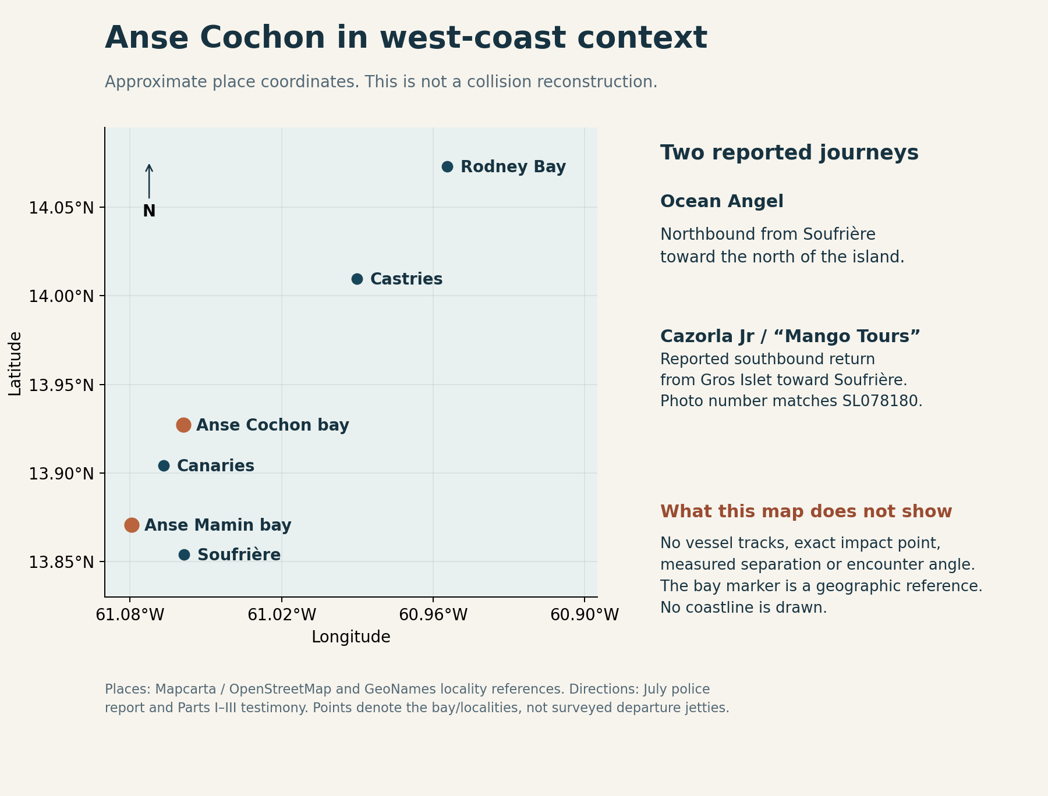
Geographic context. Approximate locality and reported journey directions are shown for orientation. The exact impact position, tracks, headings and distances require documentary verification; this is not a navigational chart or collision reconstruction.
The SL078180 photo anchors the Cazorla identity discussion. The Ocean Angel #3 assessment now rests on the expanded photo set, with the 857/875 discrepancy and unknown dates stated beside the imagery. The selected bow and empty-interior views support discussion of visible structure; they do not authenticate every image as one hull. Excluded fleet comparators and unidentified profile images remain archival references. The Mango website links an Instagram account named cazorla.jr; that is a corroborating business association, not proof of a person's ownership or a dated image. [S09, S13–S15]

How to read the visual evidence
The vessel roles, partial manifests and event sequence are supported at different levels. A photograph can explain visible layout, but cannot establish an exact impact angle, a measured speed, or an occupant's path during the collision. The reported northbound and southbound journeys are geographic context. They do not establish a head-on encounter.
Ocean Angel's lighting has three distinct evidential stages: admitted off at departure, claimed on after the helm change, and disputed immediately before impact. Pascal's account of a successful request to slow down belongs to Cazorla Jr.; it is separate from the alleged ignored warnings aboard Ocean Angel. The sequence below keeps the two voyages and witness perspectives distinct. Its stages do not imply measured durations.
Contact geometry remains unresolved. Breakup and overturning are attributed descriptions for Ocean Angel; sinking is Pascal's account of Cazorla Jr. The yacht or catamaran appears as Pascal's stated refuge after leaving the casualty craft, not as one of the two collision vessels. Its identity and position remain unknown in the materials reviewed.
A physical reconstruction would require dated hull surveys and damage photographs, complete vessel dimensions and loading, surviving light and steering components, verified positions and tracks, reliable timestamps, and qualified technical analysis. No illustration can replace that evidence.

The witness accounts in sequence
Stage | Ocean Angel account | Cazorla Jr. account | Evidence limit
Before return journey | Tyrone initially at helm; nine aboard in reconciled account | Tyson captain; nine aboard; owner says no licence check or briefing | No authenticated departure manifests
Under way | Dylan takes over; says lights switched on; passengers dispute lighting and speed | Owner asks slow down near Windjammer; says Tyson complies; later jacket stop | Approximate order; no synchronized clock or measured speeds
Approach | Dylan says sees red/green lights and turns starboard | Tyson reports seeing no approaching craft; Pascal cannot see beyond bow | Own lookout's oral account absent; no verified tracks
Contact | Breakup and overturning described | Owner thrown forward; steering disconnected after impact | Survey and physical injury reconstruction needed
Immediate response | Floating jackets/fragments, calls and rescue described | Tyson goes to help; owner and lookout attempt shoreward movement; sinking | Accounts describe different actions and perspectives
After leaving casualty craft | Canaries landing reported by Elias | Pascal swims to yacht/catamaran and calls aunt using borrowed phone | Refuge boat identity and full rescue/call timeline missing

[P1 02:08:40–02:18:22, 02:40:08–02:47:03; P2-005–P2-011, P2-041–P2-043; P3-019, P3-025–P3-028, P3-052–P3-053]

12 The first sitting in summary

Anse Cochon hearing exposes safety omissions and a gap between paperwork and practice
The first public sitting into the Anse Cochon collision heard admissions about omitted safety procedures and expired licensing, then a boat owner's account of a master named on his paperwork who, he said, never actually drove his vessel. The evidence raises substantial questions about how boats were operated and checked. It does not yet settle how the collision occurred or who caused it.
Six witnesses gave evidence across the supplied transcripts of the 13 October sitting. The collision on 18 July claimed four lives. Police named those who died as Mhakeida Nestor, Debbie Dolor, Marley William and Tyrone Elivique. The hearing uses Tyrone Paul; that naming difference needs confirmation from the official records and family.
Ireanius Pascal, whose first-name spelling remains to be checked against the witness list, identified himself as Cazorla Jr.'s owner. He said he had not checked Tyson Hippolit's licence before allowing him to captain the boat that night. Earlier, Hippolit accepted the expiry date on a licence put to him and acknowledged operating without a current licence.
Pascal said his regular captain was Daryl Paul, who was unavailable for the trip because he had taken his own boat to the event. Pascal described using Graham Matthew's name on the vessel's paperwork after SLASPA raised a qualification issue concerning Paul. He said Matthew never drove for him. He maintained that Paul held a licence, had operated for him for years and was accepted by his insurer.
That testimony requires answers from SLASPA and the people named. The complete certificates, licence grades, operating restrictions and any approved staffing arrangements have not been supplied with these transcripts. The owner's admission should not be turned into an unsupported finding of forgery or official complicity. A September expiry mentioned for Matthew's licence was after the July collision.
On safety preparation, Pascal accepted that no briefing took place, no flares were aboard and the working radio was not used to report the voyage. He described different habits when travelling with locals and conducting tourist tours. He also said Taylor, one passenger, paid funds for herself and her boyfriend. His account therefore needs more precise examination than simply calling the voyage a private party trip or assuming every person paid a fare.
Pascal said he asked Hippolit to slow down near Windjammer because of the choppy sea. He said the captain complied immediately and did not accelerate again. He described a later stop to retrieve a life jacket requested by Taylor for her boyfriend, Roman. Those details require comparison with the passengers' statements, which the Commission had earlier heard were awaiting collection.
Ocean Angel's operator, Dylan Nicholas, accepted that his boat left Soufrière with its navigation lights off and that no safety briefing was given. He said he switched the lights on when he took over from Tyrone. Passengers Roxan Bonapart and Elias Nicholas said they saw no lights during the journey. They also raised concerns about speed and requests for protection. Nicholas disputed being asked to slow down. The competing accounts remain unresolved.
Pascal's evidence makes Cazorla Jr.'s fate clearer. He said steering was disconnected after impact, although the engine remained running. He and the lookout attempted to bring the boat closer to shore with people still aboard, but it sank. He said he then swam to a nearby yacht or catamaran and borrowed a phone to call his aunt. He explained that panic left her number as the one he remembered. The record does not yet establish when the first emergency alert was received from anyone.
Ocean Angel witnesses described that craft breaking up and overturning. Neither boat is established as having survived in serviceable condition. A photograph on a Mango Tours listing carries registration SL078180, matching official identification of Cazorla Jr.; its date remains unverified. Further photographic research supports Ocean Angel #3 as the highly likely vessel identification. The available images and official notices nevertheless contain differing 857 and 875 registration endings. Historic registry records and original dated photographs are needed to resolve whether this reflects a marking or documentary error, distinct hulls or an official change.
At the 13 October sitting, the Commission heard that the investigation file was unfinished. The statements, survey evidence, movement diaries, logs and response procedures outstanding then could be decisive in resolving what happened. SLASPA's role matters because its maritime division handles vessel and operator certification and technical investigation functions. An official certificate is only part of the question; the inquiry must also establish what happened on the actual voyage.
The completed day's testimony supports scrutiny of preparation, staffing and oversight. Final collision responsibility, measured speeds, the effect of alcohol and the contribution of rescue timing to individual deaths remain unresolved. The chair adjourned the hearing to 10 a.m. on 14 October, according to the closing transcript.
The summary above draws on the attributed evidence and source references in sections 1–9. The detailed analysis identifies the contested propositions and documentary limits.

13 Questions and records still needed
These questions identify evidence that could materially change the analysis. They are a public research agenda, not a record of requests sent or responses received. The hearing record and materials reviewed establish the status described below as of the evidence cutoff.
Priority and addressee | Precise question or record request | Why it changes the story
1 Commission secretariat | Certified witness list; all three recordings; admitted exhibits; full four-page Pascal statement; chair's procedural rulings | Resolve names, speaker attributions, document wording and corrections
1 SLASPA Division of Maritime Affairs | Historical entries for SL077875 and SL077857; Cazorla SL078180; original certificates, carving notes, hull IDs, May and January documents and endorsements | Resolve the 857/875 history and physical hull identity, capacity, manning and night limits
1 SLASPA and Pascal | Why was Graham Matthew named? What was Daryl Paul's licence and why was a different grade sought? Were substitutions approved, and how recorded? | Test the gap between owner's account, administrative requirements and actual practice
1 Graham Matthew and Daryl Paul | Were you aware of the listed roles, did you consent, and what voyages or work did you perform? Supply relevant licence and appointment records | Both are materially named without oral evidence in these parts; give precise propositions and a fair response opportunity
1 Tyson and Pascal | Reconcile slowdown, jacket stop, lookout position, any warnings, neutral selection, departure from helm and later attempt toward shore | Build a coherent sequence without treating successive actions as contradictions
1 Taylor, Roman and Butcher | Confirm names, who boarded, lights seen, jacket request and use, speed changes, lookout warning and post-impact actions | First-hand accounts can test key claims currently known only through others
1 Police and surveyors | Original wreck photographs and surveys, location/time metadata, recovery records, custody and inspection notes | Test the competing contact-side propositions and distinguish pre- from post-impact damage
1 Police Marine Unit and emergency responders | First alerts, call recordings, dispatch/launch/arrival times, vessel tracks, rescue transfers and hospital handover times | Establish response chronology before assessing avoidable delay
2 Operators and insurers | Approved skipper/crew arrangements, policy schedules, inspection history, role changes and notice to insurer | Check operating permission without publishing unnecessary personal or financial data
2 Photo owners and operators | Original dated images of SL078180 and Ocean Angel III; full-resolution 857/875 markings, hull changes, source pages and photographer permission | Authenticate vessel appearance and obtain publication rights; public visibility alone is not permission
2 SLASPA and Ministry | Accident-report receipt, statutory safety-investigation decision and start records, investigator appointment, interim recommendations | Assess the existing 2021 preventive process separately from criminal inquiry and public Commission
2 Commission secretariat and counsel | Dated exhibit list, outstanding-document tracker, recall timetable, submission instructions and written rights guidance | Test whether the hearing's procedural commitments become an accessible, complete record
2 Medical and technical witnesses | Relevant pathology and rescue chronology; evidence of injury, immersion, flotation and survival opportunities | Separate collision causation from individual outcomes without assuming a jacket or faster rescue would certainly have prevented a death
2 Operators and relevant witnesses | Drink timing and amounts, direct observations, relevant medical evidence and work/rest history | Assess alcohol and fatigue without converting consumption or hours worked into a finding of impairment
2 Commission and responsible agencies | Which interim preventive actions follow from evidence already secured, who is responsible, and when will they be reviewed? | Safety improvements can proceed while disputed collision mechanics remain open

The supplied first-sitting record does not include SLASPA's detailed explanation of the certification decisions or direct testimony from Graham Matthew and Daryl Paul. Their accounts and the original records could materially change the analysis. Nothing here suggests that either person refused to testify or respond. An absent response in this record does not corroborate an allegation.
Further evidence may correct a source's answer, resolve a transcription uncertainty, contradict an earlier account or produce a Commission finding. Those are different developments. The source passages provide a basis for checking future corrections against the original account.

Appendix A People and documents named in the source identification status
“Listed” means the investigator named a written statement, not that the person testified in these parts. The table distinguishes sworn witnesses from people mentioned or listed. Unverified source renderings are retained as identification leads, not asserted as settled personal identities. Outstanding or received status describes the 13 October sitting, not a later assessment of the investigation file.
Name or source rendering | Appearance/status | Source locator
Corporal 153 Luciano — surname unverified | Sworn investigator; own four-page statement | P1 00:17:00–00:21:08
Roxan Bonapart — spelling unverified | Sworn passenger; five-page statement | P1 00:32:51; 01:06:11 onward
Dylan Nicholas | Sworn operator; four-page statement; Boatmaster certificate | P1 00:32:51–00:34:59; 02:01:11 onward
Elias Nicholas | Sworn passenger in Part II; police statement absent | P1 00:45:21; P2-001 onward
Tyson Hippolit | Sworn other master in Part II; statement corrected to four pages; licence | P1 00:27:42–00:28:51; 00:35:47; P2-035 onward
Ireanius / Ireneius / Irinius Pascal | Sixth sworn witness in Part III; adopts four-page 19 July statement; owner aboard Cazorla Jr. | P1 00:25:10–00:27:42; P3-001–P3-003
Unresolved name — source rendering “Kenisonson Jamari” | Listed police statement, two pages; request to PC 730 Jamari | P1 00:21:08–00:22:46; 00:39:10
Unresolved name — source rendering “Ji Gonzag” | Listed police statement, three pages; request to PC 918 Gonzag | P1 00:22:46; 00:37:54–00:39:10
Unresolved name — source rendering “Lily May Dashville” | Listed police statement, two pages; request to WPC 951 Dashville | P1 00:22:46; 00:39:10
Unresolved name — source rendering “Shy Smith” | Listed police statement, two pages; request to WPC 461 Smith | P1 00:22:46; 00:39:10
Unresolved name — source rendering “Ny Harris” | Listed police statement, two pages; request to PC 954 Harris | P1 00:23:31; 00:37:54
Hazel Innocent | Listed police statement, three pages; request to PC 942 Innocent | P1 00:23:31; 00:37:54
Unresolved name — source rendering “Tyresa Teet” | Listed statement, four pages; role/name unresolved | P1 00:23:31
Unresolved name — source rendering “Mario Chico” | Listed statement, three pages; role/name unresolved | P1 00:23:31
Unresolved name — source rendering “Irvin Kut Alfred” | Listed statement, four pages; role/name unresolved | P1 00:24:26
Unresolved name — source rendering “Immani Senqua” | Listed statement, two pages; role/name unresolved | P1 00:24:26
Unresolved name — source rendering “Denlin Samuel” | Listed statement, two pages; spelling questioned | P1 00:24:26–00:25:10
Larry John | Listed statement, three pages | P1 00:26:19
Unresolved name — source rendering “General BHA” | Listed statement, four pages; severely corrupted name | P1 00:28:51–00:31:20
Ralph Edward | Listed statement, three pages | P1 00:31:20
Unresolved name — source rendering “Chris Japatis” | Listed statement, three pages; spelling unresolved | P1 00:31:20
Charlene Charles | Listed statement, three pages | P1 00:31:20
Unresolved name — source rendering “Deborah Judge” | Listed statement, two pages; spelling unresolved | P1 00:31:20
Unresolved name — source rendering “Zorya Jamari” | Listed statement, three pages; spelling unresolved | P1 00:31:20–00:32:51
PC 200 Smith | Statement request listed; link to other Smith unresolved | P1 00:39:10
Corporal 256 Stannis | Requested police statement outstanding at the sitting | P1 00:40:15–00:42:49
Sergeant 271 Deise/Diss | Previously missing; statement since received | P1 00:42:49–00:43:56
Acting Corporal 478 Edwin | Previously missing; statement since received | P1 00:42:49–00:43:56
Acting Corporal 59 Anthony | Previously missing; statement since received | P1 00:42:49–00:43:56
Acting Corporal 407 Johnson | Statement outstanding at the sitting | P1 00:42:49–00:43:56
Taylor Rivier/River | Cazorla passenger; owner says paid funds and requested boyfriend's jacket; signed statement reportedly awaiting collection | P1 00:51:43–00:52:34; P3-021, P3-028
Rome / Roman William | Cazorla passenger; boyfriend for whom jacket requested; name crosswalk provisional | P1 00:51:43–00:52:34; P3-008, P3-028
Peter Joseph | SLASPA surveyor; visited scene; statement requested | P1 01:00:24–01:02:54
Wilbur ATN/Etienne | SLASPA surveyor; visited scene; statement requested; spelling unverified | P1 01:00:24–01:02:54
Mr Alexander | Maritime director as recalled/put to investigator; report discussed | P1 00:57:13–00:58:03
Graham Matthew | Named on certificates; owner says he never drove Cazorla Jr.; not heard orally in these supplied parts | P1 03:25:08–03:28:05; P3-033–P3-044
Daryl Paul | Regular Cazorla skipper per owner; listed crew; owner says absent from incident boat; not heard orally in these supplied parts | P3-034–P3-039
Janelle / Jonel Butcher; Mado / Mavado / Movado | Alias linked on record; return lookout per owner; own oral account absent from these supplied parts | P3-020, P3-048–P3-052
Tyrone/Paul; Debbie; unnamed Choiseul woman; Bradley; Marvin; Marley | Ocean Angel occupants named in testimony; not sworn here | P2-031
Lester and Nile | Mentioned in quoted owner statement; no verified complete manifest | P2-051
Woman in audience, name garbled | Says she is a bereaved mother; asks to hear Nicholas's response | P1 01:52:45–01:56:58

The police bundle also contains a fourteen-page summary of facts, supplementary report, forty-three pages of postmortem material, vessel certificates, Ocean Angel insurance papers, request letters and a three-page investigation diary. Listing these does not disclose their full contents or convert them into findings. [P1 00:21:08–00:40:15]

Appendix B Source and citation key
P1 refers to elapsed timestamps in Commission_of_Inquiry_Oct_13_2026.md. P2-001 through P2-051 refer to reproducible editorial reading blocks in the companion organised transcript. Part II supplies no timestamps; none have been invented. P3-001 through P3-057 use the same editorial-block method for Part III. P2 and P3 fine units provide more precise anchors without inventing speaker attribution. The JSON ledgers retain source excerpts, character offsets and claim IDs. All three originals remain preserved. No ASR correction should conceal a materially uncertain name or number.
Public sources and photo leads were checked on 13–14 October 2026. The hearing-testimony cutoff remains the close of 13 October. Government mirrors and copied police releases are one source family, not multiple independent witnesses. Legal references use the publicly available revised laws; any later amendment and each vessel-specific condition should be checked before a definitive legal claim.
S01 Government of Saint Lucia, commissioners sworn in, 8 September: https:/​/​www.​govt.​lc/​news/​commissioners-​sworn-​in-​for-​anse-​cochon-​maritime-​collision-​inquiry
S02 Government, first public sitting notice, 9 October: https:/​/​www.​govt.​lc/​news/​public-​sitting-​of-​the-​commission-​of-​inquiry-​into-​the-​anse-​cochon-​marine-​collision-​to-​commence-​october-​13-​2026
S03 RSLPF statement, reproduced 22 July: https:/​/​stlucianewsnow.​net/​police-​confirm-​four-​dead-​in-​anse-​cochon-​marine-​collision/​
S04 St Lucia Times, police identification and vessel-condition update, 19 July: https:/​/​stluciatimes.​com/​182192/​2026/​07/​update-​police-​identify-​two-​women-​killed-​in-​boat-​crash/​
S05 St Lucia Times, family and survivor reporting, 4 August: https:/​/​stluciatimes.​com/​182590/​2026/​08/​loved-​ones-​remember-​victims-​of-​anse-​cochon-​boat-​tragedy/​
S06 St Lucia Times, police investigation update, 20 August: https:/​/​stluciatimes.​com/​183149/​2026/​08/​police-​unable-​to-​share-​details-​of-​lester-​jean-​charge/​
S07 CMC report carrying SLASPA's account, 22 July: https:/​/​www.​thestkittsnevisobserver.​com/​st-​lucia-​government-​to-​set-​up-​commission-​of-​inquiry-​into-​deadly-​boating-​accident/​
S08 Saint Lucia Meteorological Services, 6 p.m. forecast, 18 July: https:/​/​met.​gov.​lc/​2026/​07/​18/​30553/​
S09 Mango Tours TripAdvisor listing and SL078180 photograph: https:/​/​www.​tripadvisor.​in/​Attraction_​Review-​g147345-​d27163359-​Reviews-​Mango_​Tours_​St_​Lucia-​Soufriere_​Soufriere_​Quarter_​St_​Lucia.​html ; direct image: https:/​/​media-​cdn.​tripadvisor.​com/​media/​attractions-​splice-​spp-​720x480/​12/​54/​4b/​b8.​jpg Dossier display copy: faces softened for privacy using an AI-assisted edit; the unedited source is kept in the research archive.
S10 Ocean Angel company fleet photographs: https:/​/​www.​oceanangelboattours.​com/​our-​boats
S11 Ocean Angel traveller reviews, including Alex B December 2023 review naming Ocean Angel 3: https:/​/​www.​tripadvisor.​co.​uk/​Attraction_​Review-​g147345-​d1380435-​Reviews-​or50-​Ocean_​Angel_​Boat_​Tours-​Soufriere_​Soufriere_​Quarter_​St_​Lucia.​html
S12 Company-linked Ocean Angel Facebook profile: https:/​/​www.​facebook.​com/​oceanangelwatertaxiandboattoursservices
S13 Mango Tours business website linking Instagram cazorla.jr and Facebook profiles: https:/​/​www.​mangosaintlucia.​com/​
S14 Photograph supplied to SLPA by Kevin L. Michel, beach view caption (3).jpg and accompanying fleet-exclusion observations. OCEAN ANGEL name and apparent SL077875 registration visible; digit reading qualified. Originating source URL, photographer, capture date and original publication date not supplied; no EXIF date available. No public URL assigned.
S15 Additional photographs and research supplied by Kevin L. Michel. Selected structural views: vessel 3.jpg and 2076b958-c257-4fc2-87a6-72db40f7da25.webp; two-boat view: 729186302_18096189707462311_3930841428561573244_n.jpg, background vessel apparently Ocean Angel #3 with ending 857. These are photographs supplied to SLPA, not dated registry exhibits. Original capture dates, source URLs and photographer information are unavailable; no EXIF date establishes chronology. No person is identified from appearance.
S16 Government Gazette, 25 January 2021, printed page 84, row 29: Ocean Angel Water Taxi, Ocean Angel 3rd, capacity 6, in a COVID compliance table as at 11 January 2021. No registry or unique hull identifier: https:/​/​npc.​govt.​lc/​files/​documents/​gazettes/​2021/​1/​Gazette_​January_​25_​2021.​pdf
S17 Saint Lucia Policy Analysis, continuing Anse Cochon research and policy coverage: https:/​/​www.​saintluciapolicy.​org/​research/​anse-​cochon-​marine-​safety
L32 Shipping Act, section 43, registration of alterations: https:/​/​attorneygeneralchambers.​com/​laws-​of-​saint-​lucia/​shipping-​act/​section-​43
L33 Shipping Act, section 46, registration anew on ownership change: https:/​/​attorneygeneralchambers.​com/​laws-​of-​saint-​lucia/​shipping-​act/​section-​46
L34 Shipping Act, section 47, procedure on registration anew: https:/​/​attorneygeneralchambers.​com/​laws-​of-​saint-​lucia/​shipping-​act/​section-​47
L29 Small Commercial Vessel Code, Chapter IX Part C, manning: https:/​/​attorneygeneralchambers.​com/​laws-​of-​saint-​lucia/​shipping-​act/​part-​c-​manning
L30 Same Code, Chapter VIII Part B, passenger safety and emergency preparations: https:/​/​attorneygeneralchambers.​com/​laws-​of-​saint-​lucia/​shipping-​act/​part-​b-​preparations-​for-​emergencies
L31 Same Code, application and interpretation: https:/​/​attorneygeneralchambers.​com/​laws-​of-​saint-​lucia/​shipping-​act/​part-​a-​application-​and-​interpretation
L1 SLASPA, Division of Maritime Affairs remit: https:/​/​storage.​slaspa.​com/​contentPages/​view/​about-​the-​division
L2 Shipping Act, Small Commercial Vessel Code, licences: https:/​/​attorneygeneralchambers.​com/​laws-​of-​saint-​lucia/​shipping-​act/​part-​a-​licences
L4 Shipping Act, section 476H, inspection-certificate compliance: https:/​/​attorneygeneralchambers.​com/​laws-​of-​saint-​lucia/​shipping-​act/​section-​476h
L5 Shipping Act, section 437, casualty inquiries: https:/​/​attorneygeneralchambers.​com/​laws-​of-​saint-​lucia/​shipping-​act/​section-​437
L6 Shipping Act, section 438, investigation powers: https:/​/​attorneygeneralchambers.​com/​laws-​of-​saint-​lucia/​shipping-​act/​section-​438
L8 Shipping Act, section 241, assistance after collision: https:/​/​attorneygeneralchambers.​com/​laws-​of-​saint-​lucia/​shipping-​act/​section-​241
L9 Small Commercial Vessel Code, operational requirements: https:/​/​attorneygeneralchambers.​com/​laws-​of-​saint-​lucia/​shipping-​act/​part-​a-​operational-​requirements
L10 Shipping Act, section 358, wreck reporting: https:/​/​attorneygeneralchambers.​com/​laws-​of-​saint-​lucia/​shipping-​act/​section-​358
L11 Shipping Act, section 369, salvage/breaking up: https:/​/​attorneygeneralchambers.​com/​laws-​of-​saint-​lucia/​shipping-​act/​section-​369
L12 Shipping Act, section 368, dangerous/obstructive wrecks: https:/​/​attorneygeneralchambers.​com/​laws-​of-​saint-​lucia/​shipping-​act/​section-​368
L16 UK Maritime and Coastguard Agency, international collision-rule guidance on restricted visibility: https:/​/​www.​gov.​uk/​government/​publications/​mgn-​369-​mf-​amendment-​1-​navigation-​safety-​navigation-​practices-​relevant-​to-​restricted-​visibility/​mgn-​369-​mf-​amendment-​1-​navigation-​safety-​navigation-​practices-​relevant-​to-​restricted-​visibility
L17 Attorney General's indexed COLREG light rules: https:/​/​attorneygeneralchambers.​com/​laws-​of-​saint-​lucia/​shipping-​act/​part-​c-​lights-​and-​shapes — indexed text available; direct page retrieval failed. Detailed ranges were not independently verified from that page..
L18 International Maritime Organization, COLREG overview: https:/​/​www.​imo.​org/​en/​about/​conventions/​pages/​colreg.​aspx
L24 Shipping (Accident Reporting and Investigation) Regulations 2021, regulation 9, decisions and commencement: https:/​/​attorneygeneralchambers.​com/​laws-​of-​saint-​lucia/​shipping-​act/​section-​9
L26 Same regulations, regulation 13, preventive objective: https:/​/​attorneygeneralchambers.​com/​laws-​of-​saint-​lucia/​shipping-​act/​section-​13-​01
L28 Same regulations, regulation 19, recommendations and responses: https:/​/​attorneygeneralchambers.​com/​laws-​of-​saint-​lucia/​shipping-​act/​section-​19-​01
Map reference points are approximate localities from Mapcarta/OpenStreetMap: Soufriere (https:/​/​mapcarta.​com/​Soufriere), Anse Mamin (https:/​/​mapcarta.​com/​19498868), Canaries (https:/​/​mapcarta.​com/​19499338), Anse Cochon bay (https:/​/​mapcarta.​com/​19499254), Castries (https:/​/​mapcarta.​com/​Castries) and Rodney Bay (https:/​/​mapcarta.​com/​35048528).​ They do not supply a collision coordinate or vessel track.
The companion organised transcript preserves the source text and provides stable locators. The 187-claim evidence register separates attributed statements, procedural matters and unresolved propositions. Original registry and certificate exhibits, both manifests, scene surveys and response logs remain central to testing this first-sitting account. Continued coverage: https:/​/​www.​saintluciapolicy.​org/​research/​anse-​cochon-​marine-​safety

